**Creating Microservices for account and loan**

**Account**

**AccountApplication.java**

package com.cognizant.account;

import org.springframework.boot.SpringApplication;

import org.springframework.boot.autoconfigure.SpringBootApplication;

@SpringBootApplication

public class AccountApplication {

public static void main(String[] args) {

SpringApplication.run(AccountApplication.class, args);

}

}

**AccountController.java**

package com.cognizant.account.controller;

import org.springframework.web.bind.annotation.*;

@RestController

@RequestMapping("/accounts")

public class AccountController {

    @GetMapping("/{number}")

    public Account getAccount(@PathVariable String number) {

        return new Account(number, "savings", 234343);

    }

}

class Account {

    private String number;

    private String type;

    private int balance;

    // constructor, getters, setters

    public Account(String number, String type, int balance) {

        this.number = number;

        this.type = type;

        this.balance = balance;

    }

    public String getNumber() { return number; }

    public String getType() { return type; }

    public int getBalance() { return balance; }

}

**OUTPUT:**

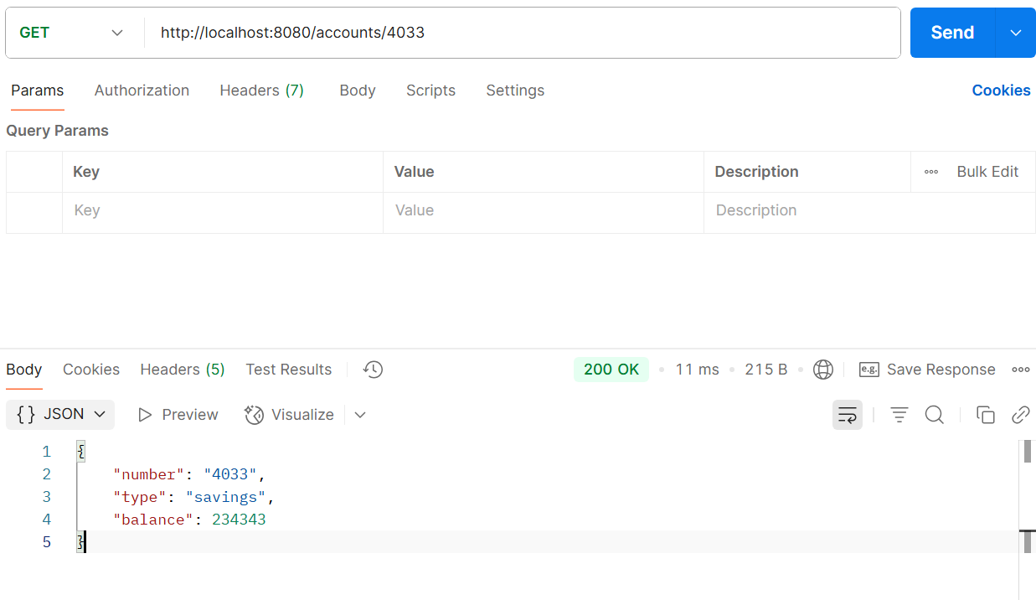

**Loan**

**LoanApplication.java**

package com.cognizant.loan;

import org.springframework.boot.SpringApplication;

import org.springframework.boot.autoconfigure.SpringBootApplication;

@SpringBootApplication

public class LoanApplication {

    public static void main(String[] args) {

        SpringApplication.run(LoanApplication.class, args);

    }

}

**LoanController.java**

package com.cognizant.loan.controller;

import org.springframework.web.bind.annotation.*;

@RestController

@RequestMapping("/loans")

public class LoanController {

    @GetMapping("/{number}")

    public Loan getLoan(@PathVariable String number) {

        return new Loan(number, "car", 400000, 3258, 18);

    }

}

class Loan {

    private String number;

    private String type;

    private int loan;

    private int emi;

    private int tenure;

    // constructor, getters

    public Loan(String number, String type, int loan, int emi, int tenure) {

        this.number = number;

        this.type = type;

        this.loan = loan;

        this.emi = emi;

        this.tenure = tenure;

    }

    public String getNumber() { return number; }

    public String getType() { return type; }

    public int getLoan() { return loan; }

    public int getEmi() { return emi; }

    public int getTenure() { return tenure; }

}

**OUTPUT:**

